**EMPLOYEE RECORD MANAGEMENT SYSTEM**

**N. SOWMIYAN**

**REGISTRATION NUMBER: BAT/IT/2017/FT/100**

**HIGHER NATIONAL DIPLOMA IN INFORMATION TECHNOLOGY**

**ADVANCE TECHNICAL INSTITUTE - BATTICALOA**

**SRI LANKA INSTITUTE OF ADWANCED TECHNOLOGICAL EDUCATION**

**2019**

**EMPLOYEE RECORD MANAGEMENT SYSTEM**

**N. SOWMIYAN**

**REGISTRATION NUMBER: BAT/IT/2017/FT/100**

**A Software project is submitted to the Department of Information and Communication**

**Technology, ATI Batticaloa in Partial Fulfillment of the Requirements of the Degree of Higher National Diploma in Information and Communication Technology.**

**HIGHER NATIONAL DIPLOMA IN INFORMATION TECHNOLOGY**

**ADVANCE TECHNICAL INSTITUTE - BATTICALOA**

**SRI LANKA INSTITUTE OF ADWANCED TECHNOLOGICAL EDUCATION**

**2019**

## DECLARATION

I do hereby declare that the work reported in this project report was exclusively carried out by me under the supervision of Mr.P.Pirupuraj of the Department of Information Technology, Advanced Technological Institute Batticaloa*,* SriLanka. It describes the result of my own and independent work except where due reference has been made in the text. No part of this project report has been submitted earlier or concurrently for the same or any other diploma.

Certified by:

1. Supervisor: ………………………….............. Date: …………………………..

Signature: ……………………

1. Head of the Department: ..................................... Date: ………………………

Signature: ...................................

## ACKNOWLEDGEMENT

The success and final outcome of this project required a lot of guidance and assistance from many people and I extremely fortunate to have got this all along the completion of our project work. Whatever we have done is only due to such guidance and assistance and I would not forget to thank them. I respect and thankful for my project supervisor Mr.P.Pirapuraj sir and other lecturers for giving us an opportunity to do this project work and providing us all support and guidance which made us complete the project on time, we extremely grateful to him for providing such a nice support and guidance.

I am really grateful because I could manage to complete this project within the time given by HOD. This project cannot be completed without the effort and co-operation from our ATI staffs. I would like to express my gratitude to my friends and respondents for support and willingness to spend some time with me.

Thank you

**ABSTRACT**

## Employee Management System

This is the document of the Project report for developing Employee Management System for ATI. It consists of the current background of the staff and problems having due to present system and how I going to overcome those matters through my proposed system.

After gathering requirements, I have to found that ATI is using a manual file based system for their processes. They are keeping a huge number of files to handle Employee details. Search for a record in the file system is really harsh although they are not well secured there is a probability of getting damaged due to a fire or any other kind of a disaster.

The project aimed to build a fully functional system in order to achieve the efficiency in the Employee Record Management. The overall mission of system development is to get Employee details as soon as possible and also can update, delete, search details of Employee.

## TABLE OF CONTENTS

**Chapter 1**

### INTRODUCTION………….……………………………………..…..……………….…1

**1.1 Introduction………….………..…………………………..…..…………………1**  **1.2 Objective………………………….……...…………………………….……...…2**

**Chapter 2**

### SYSTEM ANALYSIS……..……………………………………………...….……..…...3

**2.1 System Analysis……………………...…………………………….…….....…...3**

**2.2 Description of existing system………………………………….…………........4 2.3 Circumstances leading to the proposed system ................................................4 2.4 HardwareConfiguration......................................................................................5 2.5 Software Configuration ......................................................................................5 2.6 Requirements .......................................................................................................6**

### 2.6.1Functional Requirements ..................................................................6

**2.6.2 Non-Functional Requirements .........................................................6**

#### 2.7 Requirement Analysis .........................................................................................7

**2.7.1 Information Gathering ......................................................................7**

**2.7.2 Methodology for the project .............................................................7**

**2.7.3 Data Source ........................................................................................8**

**2.7.4 Fact Finding Techniques ...................................................................8**

**2.7.5 Data Collection Methods....................................................................8**

#### 2.8 Feasibility Analysis ............................................................................................10

**2.8.1 Technical Feasibility: .......................................................................10**

**2.8.2 Economical Feasibility: ....................................................................10**

**2.8.3 Schedule Feasibility: .........................................................................10**

### Chapter 3

**UNIFIED MODELING LANGUAGE..........................................................................11**

#### 3.1 UML Diagrams: .................................................................................................11

##### 3.1.1 Use Case Diagram ............................................................................12

**3.1.2 Class Diagram …..............................................................................13**

**3.1.3 Activity Diagram..............................................................................14**

**Chapter 4**

### SYSTEM DESIGN..........................................................................................................15

#### 4.1 Introduction..................................................................................................15

#### 4.2 Interface design ............................................................................................15

#### 4.3 Database design ...........................................................................................15

**4.3.1 DFD Diagram ........................................................................15**

**4.4 ER Diagram…………………………………………………………………16**

### Chapter 5 DATABASE MANAGEMENT .....................................................................................17

#### 5.1 Database Management System..........................................................................17

#### 5.2 Database Backup ...............................................................................................17

**5.2.1 Backup Data ............................................................................17**

**5.2.2 Backup Media ..........................................................................17**

### Chapter 6 INTERFACE DESIGN .................................................................................................18

**6.1 Interface Designs ................................................................................................18**

**6.2 Software Interfaces ............................................................................................18**

**6.3 Software Database …………………………………………………………......23**

### Chapter 7

### SYSTEM IMPLEMENTATION ..................................................................................24

**7.1 End user Training: ..............................................................................................24**

**7.2 End User Education: ...........................................................................................24**

**7.3 Training of application software: ......................................................................24**

**7.4 Post Implementation View: ................................................................................25**

### Chapter 8

### SOFTWARE TESTING ................................................................................................26

**8.1 White Box Testing ..............................................................................................26**

**8.2 Black box Testing ...............................................................................................27**

**8.3 Scope of Testing ..................................................................................................27**

**8.4 Test Plan. .............................................................................................................27**

**Chapter 9**

### CRITICAL APPRAISAL OF PROJECT ....................................................................28

#### 9.1 Critical Appraisal of Project ............................................................................28

**9.1.1 Review of the Project Development Process ...............................28**

#### 9.2 Strengths and Weaknesses ................................................................................28

**9.2.1 Strengths .........................................................................................28**

**9.2.2 Weaknesses .....................................................................................28**

**9.3 Future Scope…....................................................................................................28**

### Chapter 10

### CONCLUSION ................................................................................................................29

**10.1 Conclusion .......................................................................................................... 29**

**10.2 Reference............................................................................................................. 29**

## LIST OF FIGURES

**Figure 3.1: Use Case Diagram.........................................................................................12 Figure 3.2: Class Diagram...............................................................................................13 Figure 3.3: ActivityDiagram…………………................................................................14 Figure 4.1: Data Flow Diagram…...................................................................................15 Figure 4.2: ER Diagram………………………………………………………………...16 Figure 6.2.1: Splash Screen& Login Form.....................................................................18 Figure 6.2.2: All Employee Form....................................................................................19 Figure 6.2.3: Current Employee Form...........................................................................19 Figure 6.2.4: Past Employee Form…….….......................................................................20 Figure 6.2.5: Add Employee Form …….........................................................................20 Figure 6.2.6: Add User Form ..........................................................................................21 Figure 6.2.7: Setting Form.….........................................................................................21**

**Figure 6.2.8: Employee Details Form ............................................................................22**

**Figure 6.2.9: Print Preview Form ..................................................................................22**

**Figure 6.3.1: Admin Database ………............................................................................23**

**Figure 6.3.2: Employee Database ……….......................................................................23**

## LIST OF ABBREVIATION

**ATI - Advanced Technological Institute**

**ER Diagram - Entity Relationship diagram**

**GUI - Graphical User Interface**

**PHP - Hypertext Preprocessor**

**PC - Personal Computer**

**SDLC - Software Development Life Cycle**

**SLIATE -** **Sri Lanka Institute of Advanced Technological Education**

**SQL Server - Structure Query Language Sever**

**RAM - Random Access Memory**

**UC - Use Case**

**UML - Unified Modeling Language**

**Chapter 1**

**INTRODUCTION**

## 1.1 Introduction

This Employee Management System has all the features required for all Sri Lanka Institute of Advanced Technological Education (SLIATE) to function seamlessly. It is very friendly to use and manage all operations of a Sri Lanka Institute of Advanced Technological Education (SLIATE) very effectively. This software can be set up for your unique needs. This Employee Management System has been conceived by blend of seasoned professional. It is geared up to meet the demands of running a modern SLIATE. This system will give full solution for the manual system. It will work on network so that multiple users will be able to work on this system simultaneously. It is a comprehensive software suite consisting of integrated modules for various aspects of Management system.

Employee Management System is a software system where the management of entire ATI is computerized. The registration system is designed using PHP as the rich GUI for front end and WAMP Server as the secured backend database. In this project and implementation, the details are maintained like Admin Access (Login page), Add data, Delete data, Update data, Report data and Print data. All are computerized and the management is done without any difficulty. The reports can be viewed completely and the head of the management monthly or yearly can review it.

Main Features are:

1. Employee Management System.
2. System Login, Logout
3. Username and Password.
4. Order Notifications.
5. Fixed, Stationary Id’s are creating automated.
6. Database Backup and Restore.
7. Advanced Reports.
8. High Secure
9. Fast Access
10. Employee report gets printing six month, one Year

## 1.2 Objective

The main objective behind preparing this project is that to give ATI a complete facility that a ATI managerial team wants. It even helps the user to handle the managing system of the ATI properly. And it also gives the staff an easier way to have Add data and other related activities in the ATI. Besides this there are many objectives like:

* To manipulate the ATI transfers with instant confirmation.
* To save time and accuracy in work.
* To increase efficiency of staff.
* For fast access of data.
* For secure and smooth running of the program.
* For error free, effective and easy for database related works.
* To ease staff and admin with facilities for data adding process.
* To enable sharing of ideas, harmonize and provide timely useful information on how best to enhance performance.
* To easy decision making, save time and resources and utilize opportunities of new technology.

**Chapter 2**

## SYSTEM ANALYSIS

**2.1 System Analysis**

System Analysis is a detailed study of the various operations performed by a system and their relationships within and outside of the system. Here the key question is what all problems exist in the present system? What must be done to solve the problem? Analysis begins when a user or manager begins a study of the program using existing system.

During analysis, data collected on the various files, decision points and transactions handled by the present system. The commonly used tools in the system are Data Flow Diagram, Interviews and Questionnaire etc. Training, experience and common sense are required for collection of relevant information needed to develop the system. The success of the system depends largely on how clearly the problem is defined, thoroughly investigated and properly carried out through the choice of solution. A good analysis model should provide not only the mechanisms of problem understanding but also the frame work of the solution. Thus, it should be studied thoroughly by collecting data about the system. Then the proposed system should be analyzed thoroughly in accordance with the needs.

System analysis can be categorized into four parts.

* System planning and initial investigation
* Information Gathering
* Applying analysis tools for structured analysis
* Feasibility study
* Cost/ Benefit analysis.

In the current system, I need to keep a number of records related to the staff and want to enter the details of the staff and their details manually. In this system only the admin or the institute authority views the detail of the employee and they want to enter the details of the employee. This is time consuming.

## 2.2 Description of existing system

Employee Management System involves maintaining various operations of the ATI like Add data, Delete data, Update data, Report data etc. The existing system is a manual one and there is lot of issues like erroneous data, slow process, lack of security etc. Finding out the Employees who work for the office details completely relies on the ATI admin.

* Manual entry consumes more time.
* It is difficult to maintain bulk of record in manual.
* Restrictions in the users.
* Not easy to prepare the daily reports.
* Overall efficiency is less.
* Non-secure.
* No perfect maintenance of report.
* No method to trace details.
* Human errors
* Slow recording, processing and retrieval of registration details.
* Reliance on paper based work. Paper files consume a lot of the office space.
* The storing and retrieving mechanism of data wastes materials and human power.
* Data that stored in manual format is more vulnerable to damages.
* Saving employee records manually wastes too many resources (Eg: Paper, pen, ink…)
* Accessing and sharing of information by different departments is difficult due to poor information management.
* Files are prone to theft unauthorized modification due to low data security levels and standards.

## 2.3 Circumstances leading to the proposed system

* This Employee Record Management System is much more efficient and effective than the current manual system.
* Records’ searching is very fast.
* It is easier to maintain bulk of records.
* Easy to prepare the daily reports.
* Provides Correctness, Reliability, Efficiency, testability and Portability.
* Highly Secure
* Maintenance of reports.
* Provides database backup and restore facility.
* Having Chatting module for perfect communication between system users.
* All records can be updated frequently.

## 2.4 Hardware Configuration

* Processor : Intel(R) Pentium(R) CPU B960 ,2.20GHz

* RAM : 1GB or more

* Hard Disk : Minimum disk space for installing Online Course

Registration System is 1 GB

* Printer For Report Printing

## 2.5 Software Configuration

Operating System : Windows 7, Windows 8, Windows 10 (64 Bit)

Back End :WAMP Server

Language : Php

## 2.6 Requirements

### 2.6.1 Functional Requirements

Functional requirement of Employee Management System is listed below.

* Log In
* Change password
* Add, Update Employee details
* Manage Details
* Log In, Log Out Details
* View particular data
* Get Print Report
* Backup
* Log Out

### 2.6.2 Non-Functional Requirements

Non-functional requirement is a requirement that specifies criteria that can be used to judge the operation of a system, rather than specific behaviors.

The non-functional requirements of the Employee Management System are

* User friendliness
* Timeliness
* Accurate
* Security

## 2.7 Requirement Analysis

### 2.7.1 Information Gathering

Information gathering is an art of science, the aim of information gathering is to primarily develop an understanding of the problem faced by the user and nature of the operation. It also requires to get the suitable solution of the problems. The approach and manner in which information is gather require persons with sensitivity, common sense and knowledge of what and when to gather and what channels to use in securing training and experience that I have.

Information about the current system is studied to know that promotes the introduction of manual Management systems there are many loop presents in current system, information gathering of the project is done by collecting information from the organization itself, internet on site observation, go to the organization communicate with the system users.

### 2.7.2 Methodology for the project

The software development life cycle model that I used for developing this project is the agile model. Agile Development Principles

**Iterative Development:** My development strategy is Iterative development which allows the client to direct the development process in order to get the software features they want. Working software is delivered to the client at regular, short intervals. Client feedback is used to make changes to the software specifications at any stage in the development.

**Open Collaboration:** The backbone of agile development is open, unrestricted communication between programmers and clients. In addition to working closely with the clients, the programming team must be able to communicate freely with each other. Face to face communication is preferred over specification documents, so working in an open office with no cubicles is ideal.

**Adaptability:** Software must be written expecting for future change. Principles like Don't Repeat Yourself (DRY) are used to facilitate this. In agile development, changes to the software specifications are welcome even in late stages of development. As clients get more hands-on time with iterative builds of the software, they may be able to better communicate their needs.

### 2.7.3 Data Source

The data source for this project is the primary data source: -

**Staff of the ATI:** Since the ATI admin are the main beneficiaries of this project they are one of our data source. Administrators, the Owner of the ATI and other staff.

**Forms:** paper forms filled for staff and Employee record details

**Internet:** We used internet for getting Reset Password this system

### 2.7.4 Fact Finding Techniques

* Learn from existing documents, forms, reports, and files.
* If appropriate, observe the system in action.
* Given all the facts that already collected, design and distribute questionnaires to clear up things that aren’t fully understood.
* Conduct interviews (or group work sessions).

### 2.7.5 Data Collection Methods

After a simple meeting with the ATI admin, I was able to gain more details and processes that need to be considering in build the system. Requirement gathering process was performed by using some techniques such as

* Interviewing
* Observation
* Document Analysis
* Prototyping

Through this I was able to collect raw data on the System at Batticaloa ATI where existing reports on the current system were obtained. Verbal interview techniques were used to interview employees from the ATI.

#### Interview

Interviewing with the manager, workers and the head of the ATI face to face is beneficial to the system and clear out many differences regarding requirements about the system. I found the all requirements that have to be computerized such as, add data, Delete data, Update data, Report data, Print data. By refereeing to files and records that have been keeping by the ATI, I got a clear idea about the required fields. The requirements gathering, I have done helped me in identifying the entities, attributes and the relationships of the scenario of the ATI and the information. I gathered data to help to decide the data that I should handle in the system database. The functions of the system that is going to be designed has to be met with the staff requirements and the outcomes of the functions should have to be addressed the problems that I have encountered during the requirement gathering phase. The staff requirements identified.

#### Practical Observation

Watching users (in case Receptionist, finance, ATI admin) performing their day to day activities at work. I use this way to check for nonverbal expression of feelings, determine who interacts with whom, grasp how participants communicate with each other, and check for how much time is spent on various activities.

#### Document Analysis

I try to take a look on Forms, reports and some files from existing system, to better understand how the existing system is working, how documents are managed and accessed.

##### 2.8 Feasibility Analysis

The feasibility study proposes one or more conceptual solution to the problem set of the project. In software development whatever we think need not be feasible. It is wise to think about the feasibility of any problem we undertake. Feasibility is the study of impact, which happens in the organization by the development of a system. The impact can be either positive or negative. When the positives dominate the negatives, then the system is considered feasible. In fact, it is an evaluation of whether it is worthwhile to proceed with project or not. Feasibility analysis usually considers a number of project alternatives, one that is chosen as the most satisfactory solution. These alternatives also need to be evaluated in a broad way without committing too many resources.

**2.8.1 Technical Feasibility:**

I can strongly say that it is technically feasible, since there will not be much difficulty in getting required resources for the development and maintaining the system as well. All the resources needed for the development of the software as well as the maintenance of the same is available in the organization here I am utilizing the resources which are available already.

**2.8.2 Economical Feasibility:**

Development of this application is highly economically feasible. The organization needed not spend much money for the development of the system already available. The only thing is to be done is making an environment for the development with an effective supervision. If I am doing so, I can attain the maximum usability of the corresponding resources. Even after the development, the organization will not be in condition to invest more in the organization. Therefore, the system is economically feasible.

**2.8.3 Schedule Feasibility:**

Time evaluation is the most important consideration in the development of project. The time schedule required for the developed of this project is very important since more development time effect machine time, cost and cause delay in the development of other systems. A reliable Employee Management System can be developed in the considerable amount of time.

## Chapter 3

**UNIFIED MODELING LANGUAGE**

**3.1 UML Diagrams:**

UML is a language that unifies the best engineering practices for modeling systems. The following UML diagrams describe the process involved in the Employee Management System.

### 3.1.1 Use Case Diagram

Use Case (UC) diagrams are drawn to summarize who can use an application or system, and what they can do with the system. They are used to show all of the available system functionality. Use Case Diagrams have four (4) major elements: Actors, System, Use Cases, and relationships. Use Case Diagrams represent the functionality of the system from a topdown perspective.

Use Case diagrams as behavior diagrams are used to describe a set of actions (use cases) that systems (subject) should or can perform in collaboration with one or more external users of the system (actors). Each user provides some observable and valuable result to the actors or other stakeholders of the system.

UC diagrams are used to specify external requirements on a subject (required usage of a system), the functionality offered by a subject (what the system can do), and the requirements the specified subject poses on its environment.

### Actor identification

In my System, there is Two Actors which is the following

* Administrator
* Employee
* Register

### Use Case Diagram

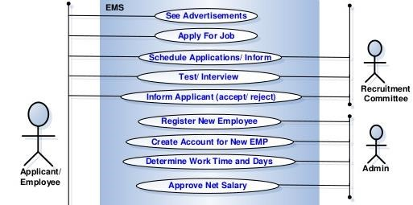

**Figure 3. 1: Use Case Diagram**

#### 3.1.2 Class Diagram

A class diagram is a static structure diagram in UML and describes the types of objects in the system and the various kinds of static relationships that exist among them. Class diagrams are main building block of object oriented modeling. It is used both for general conceptual modeling of the systematic of the application, and for detailed modeling translating the models into programming code.

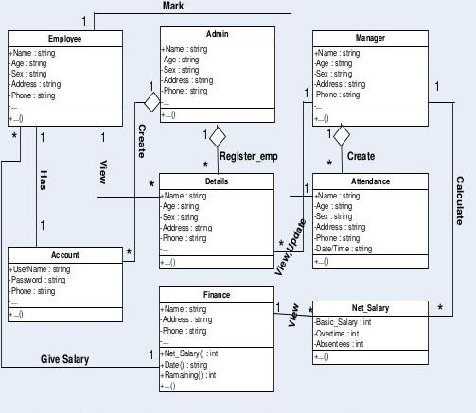

**Figure 3. 2: Class Diagram**

#### 3.1.3 Activity Diagram

Activity diagrams, which are related to program flow plans (flowcharts), are used to illustrate activities. In the external view, we use activity diagrams for the description of those business processes that describe the functionality of the business system. Contrary to use case diagrams, in activity diagrams it is obvious whether actors can perform business use cases together or independently from one another. Activity diagrams allow you to think functionally. Purists of the object-oriented approach probably dislike this fact. We, on the other hand, regard this fact as a great advantage, since users of object-oriented methods, as well as users of functional thinking patterns, find a common and familiar display format, which is a significant aid for business-process modeling. Because it is possible to explicitly describe parallel events, the activity diagram is well suited for the illustration of business processes, since business processes rarely occur in a linear manner and often exhibit parallelisms. Activity diagrams can be developed in various degrees of detail.

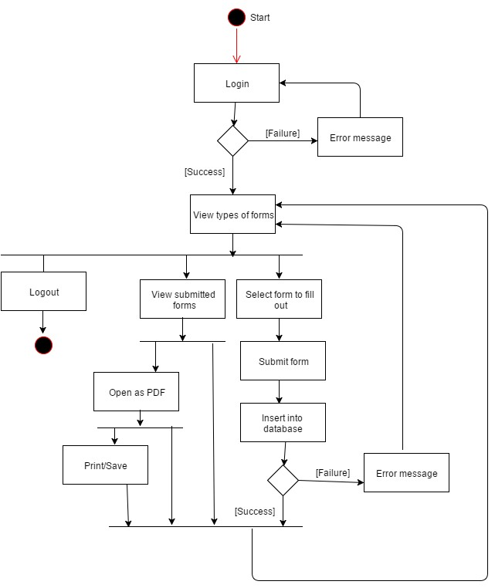

**Figure 3. 3: Activity Diagram**

**Chapter 4**

**SYSTEM DESIGN**

#### 4.1 Introduction

An overall view of the system is presented together with illustrations as how each module interacts with each other. It is here that the written specifications are translated into relevant diagrams to represent the system. This system used DFD and ER diagram for system design.

#### 4.2 Interface design

This system contains various Forms, Buttons, Textboxes, Labels, and Tables, Combo boxes, Manuscript and Picture boxes.

#### 4.3 Database design

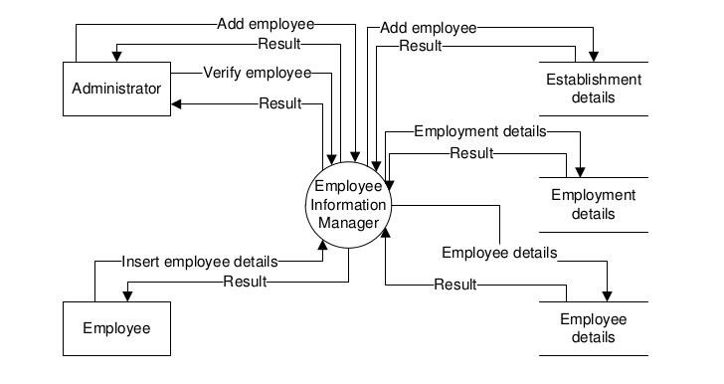

**Figure 4.1: DFD Diagram**

#### 4.4 ER Diagram

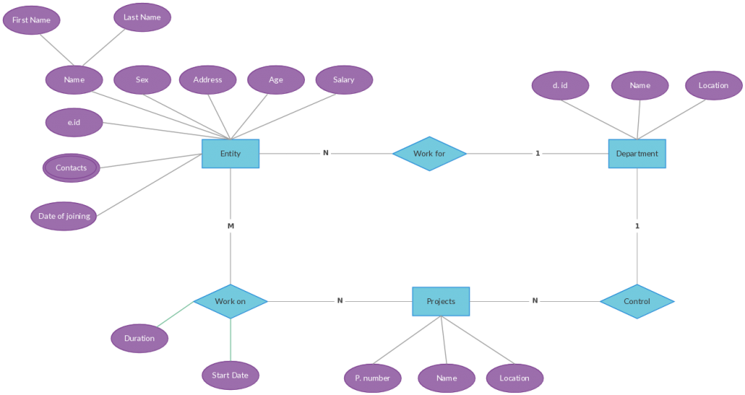

**Figure 4.2: ER Diagram**

**Chapter 5**

**DATABASE MANAGEMENT**

#### 5.1 Database Management System

A database is a collection of interrelated data stored with minimum redundancy to serve many users quickly and effectively. After designing input and output, the analyst must concentrate on database design or how data should be organized around user requirements. The general objective is to make information access, easy quick, inexpensive and flexible for other users. During database design, the following objectives are concerned: -

* Controlled Redundancy
* Data independence
* Accurate and integrating
* More information at low cost
* Privacy and security
* Performance
* Data backup and recovery
* Ease of learning and use

#### 5.2 Database Backup

Database backup is the process of backing up the operational state, architecture and stored data of database software. It enables the creation of a duplicate instance or copy of a database in case the primary database crashes is corrupted or is lost. .Backup means to [copy files t](http://www.webopedia.com/TERM/C/copy.html)o a second [medium (](http://www.webopedia.com/TERM/M/media.html)[a disk o](http://www.webopedia.com/TERM/D/disk.html)[r tape)](http://www.webopedia.com/TERM/T/tape.html) as a precaution in case the first medium fails. So, the database has day-to-day backup to saves the data from the database. Therefore, I got my backups on my external hard drive. That backup will be reused by the programmer if the database going to destroyed.

##### 5.2.2 Backup Media

* VCD / DVD / Rewritable CD Recordable
* External hard disk
* Pen drive
* E-mail accounts
* Google

**Chapter 6**

**INTERFACE DESIGN**

#### 6.1 Interface Designs

There are two types of interface design available. But I used menu based interface (GUI).

Because it has more advantages than other interfaces. Such as,

* Users easy to achieve the functions by selecting icons.
* Users not need that much of knowledge to access the system.
* Users learning time is relatively short.
* Users get immediate feedback on their actions.
* Easy to maintain.
* Saving time wastage.
* User guidance and on-line help.
* Speed of use.
* Support for multiple skill levels.

#### 6.2 Software Interfaces

Computer Interface of Employee Record Management System is user friendly. Each interface has connected with database.

When the program run, first the **Splash Screen & Log In** form will appear.

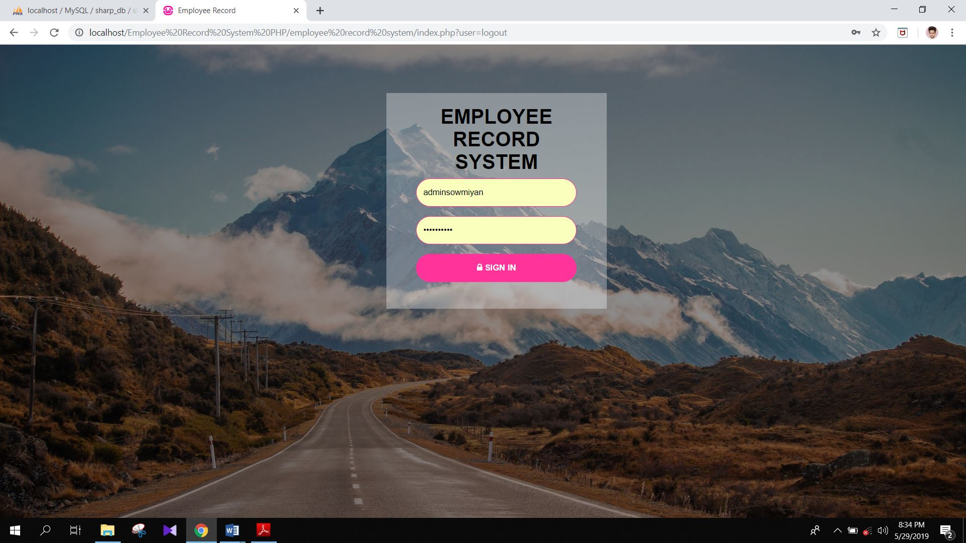

##### Figure 6.2.1: Splash Screen & Log In Form

After Login **All Employee form will appear**

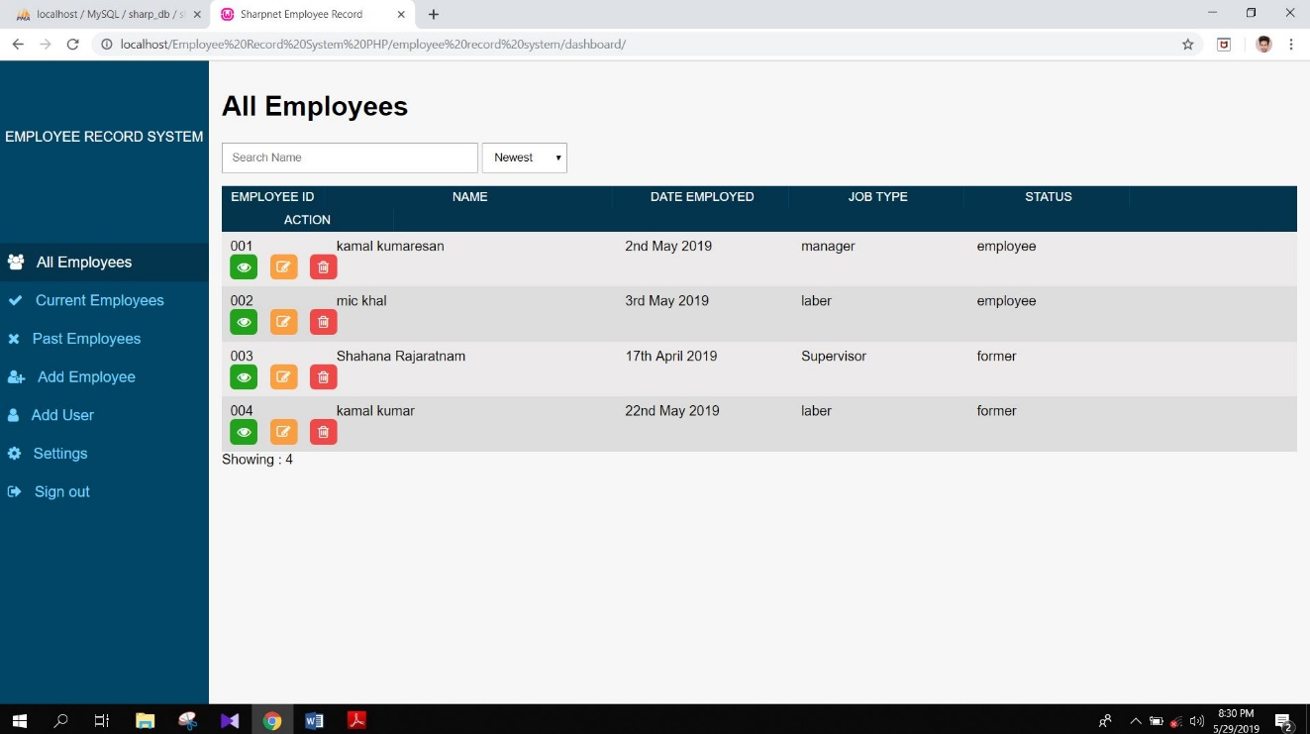

**Figure 6.2.2: All Employee Form**

Show the **Current Employee Form**

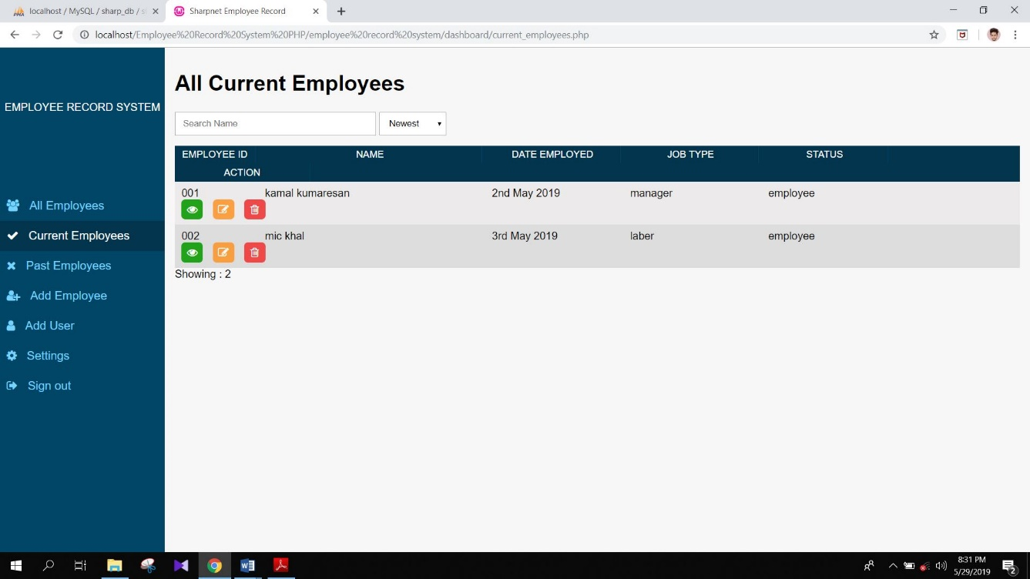

**Figure 6.2.3: Current Employee Form**

Show the **Past Employee Form**

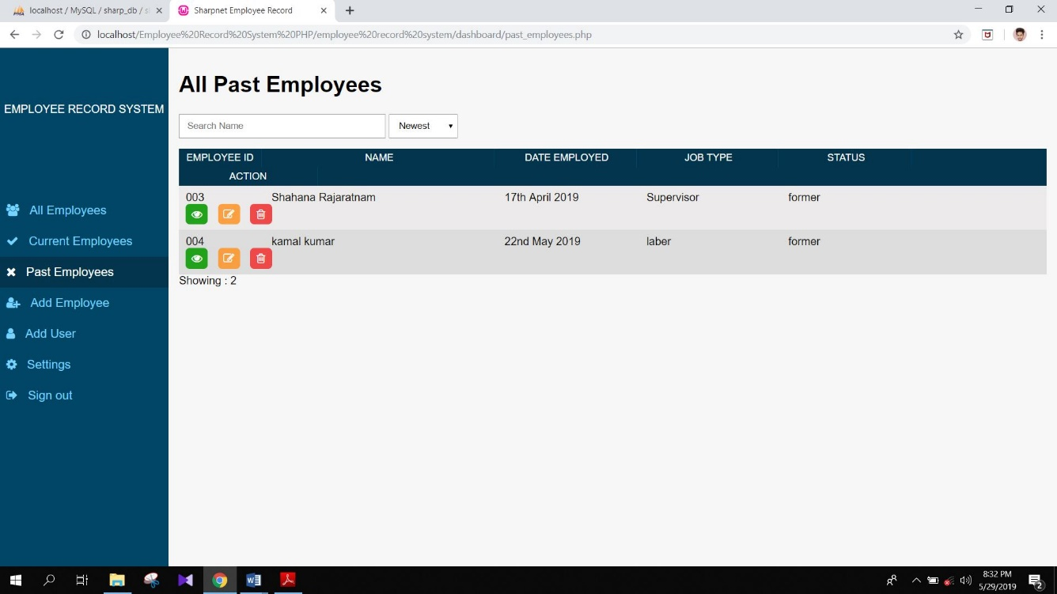

**Figure 6.2.4: Past Employee Form**

Show the **Add Employee Form**

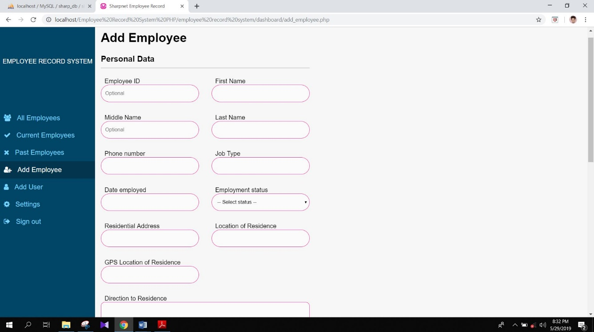

**Figure 6.2.5: Add Employee Form**

Show the **Add User Form**

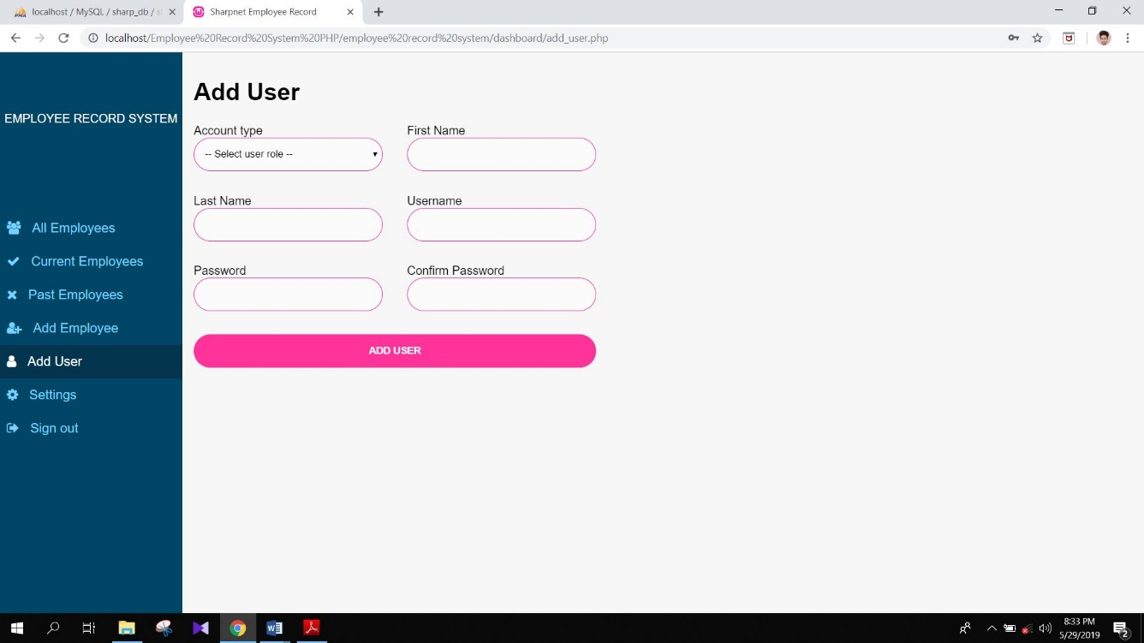

**Figure 6.2.6: Add User Form**

Show the **Setting Form**

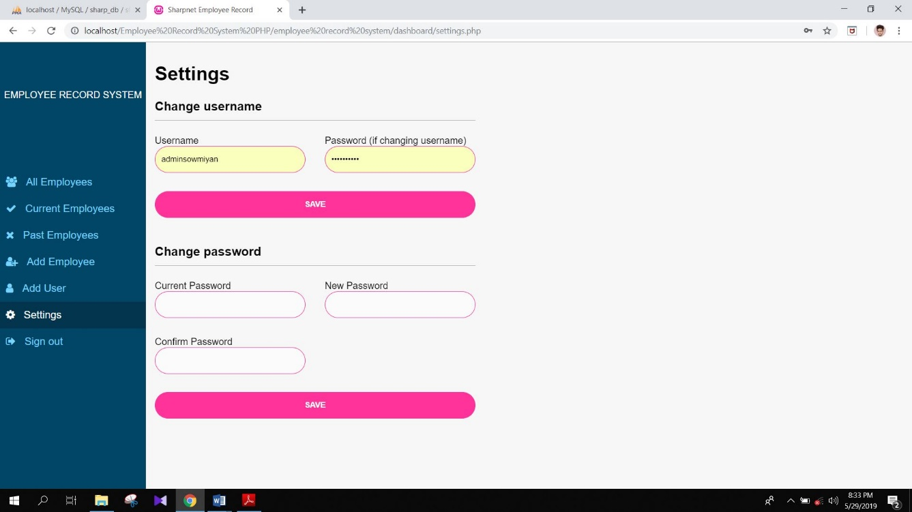

**Figure 6.2.7: Setting Form**

Show the **Employee Details Form**

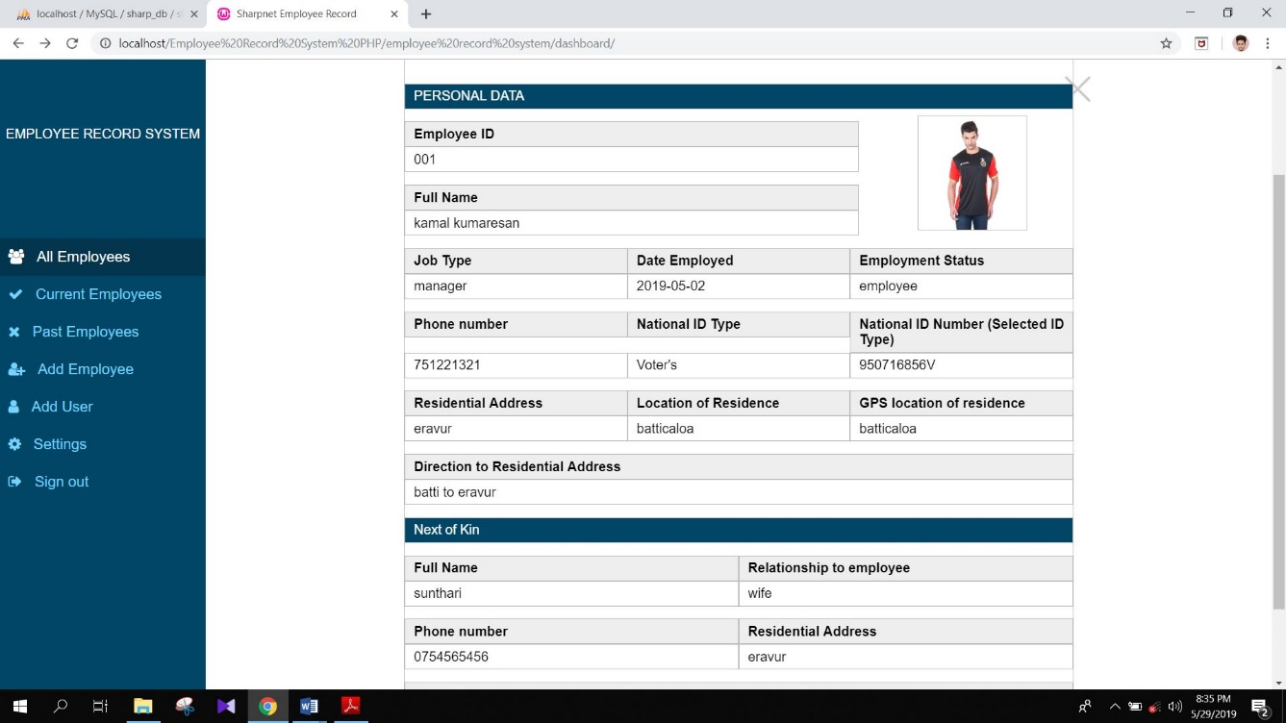

**Figure 6.2.8: Employee Details Form**

Show the **Print Preview Form**

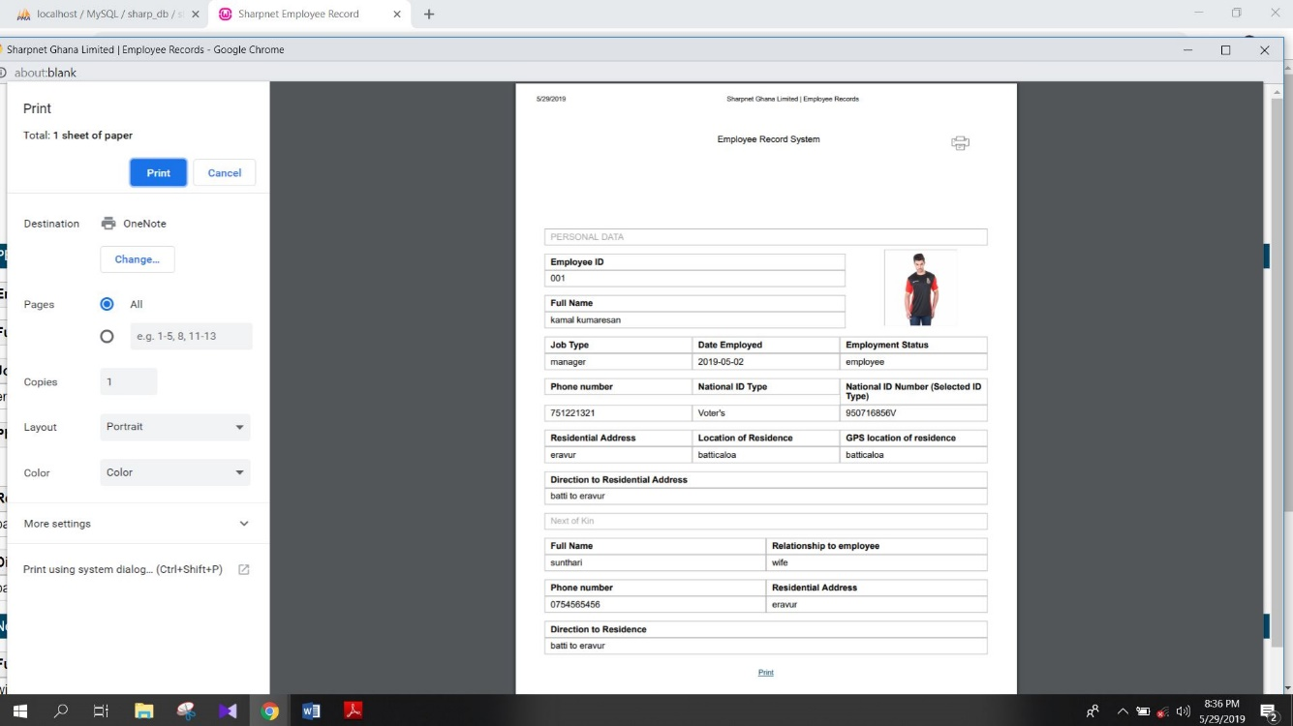

**Figure 6.2.9: Print Preview Form**

#### 6.3 Software Database

Show the **Admin Database**

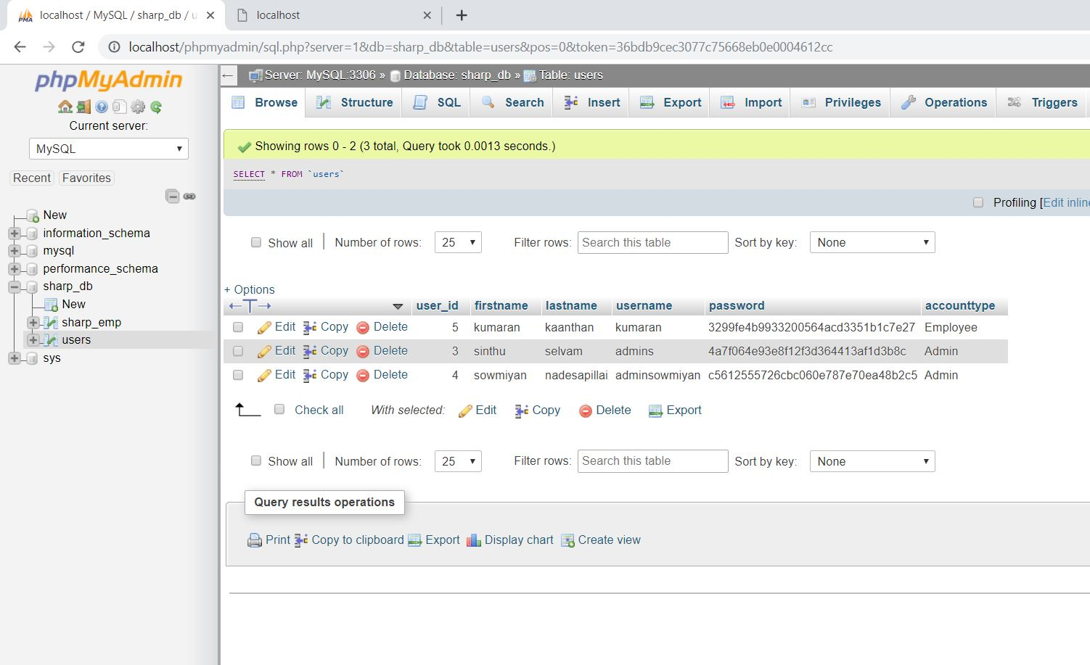

**Figure 6.3.1: Admin Database**

Show the **Employee Database**

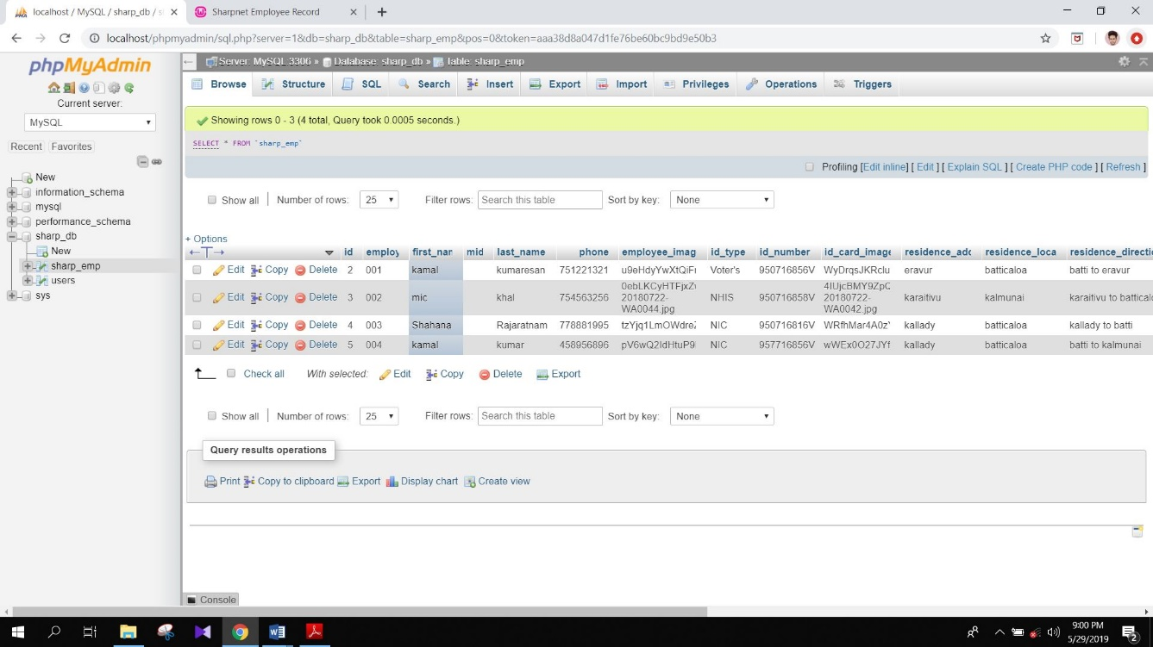

**Figure 6.3.2: Employee Database**

**Chapter 7**

**SYSTEM IMPLEMENTATION**

Implementation is the stage in the project where the theoretical design is turned into a working system. The implementation phase constructs, installs and operates the new system. The most crucial stage in achieving a new successful system is that it will work efficiently and effectively.

There are several activities involved while implementing a new project.

They are…

* End user training
* End user Education
* Training on the application software
* System Design
* Parallel Run and To New System
* Post implementation Review

* 1. **End user Training:**

The successful implementation of the new system will purely upon the involvement of the officers working in that department. The officers will be imparted the necessary training on the new technology

* 1. **End User Education:**

The education of the end user start after the implementation and testing is over. When the system is found to be more difficult to understand and complex, more effort is put to educate the end used to make them aware of the system, giving them lectures about the new system and providing them necessary documents and materials about how the system can do this.

* 1. **Training of application software:**

After providing the necessary basic training on the computer awareness, the users will have to be trained upon the new system such as the screen flows and screen design type of help on the screen, type of errors while entering the data, the corresponding validation check at each entry and the way to correct the data entered. It should then cover information needed by the specific user or group to use the system.

* 1. **Post Implementation View:**

The department is planning a method to know the states of the past implementation process. For that regular meeting will be arranged by the concerned officers about the implementation problem and success

**Chapter 8**

**SOFTWARE TESTING**

Is the menu bar displayed in the appropriate contested some system related features included either in menus or tools? Do pull –Down menu operation and Tool-bars work properly? Is all menu function and pull-down sub function properly listed? Is it possible to invoke each menu function using logical assumptions that if all parts of the system are correct, the goal will be successfully achieved? In adequate testing or non-testing will leads to errors that may appear few months later.

This creates two problems:

1. Time delay between the cause and appearance of the problem.
2. The effect of the system errors on files and records within the system

The purpose of the system testing is to consider all the likely variations to which it will be suggested and push the systems to limits. The testing process focuses on the logical intervals of the software ensuring that all statements have been tested and on functional interval is conducting tests to uncover errors and ensure that defined input will produce actual results that agree with the required results. Program level testing, modules level testing integrated and carried out.

There are two major type of testing they are:

* 1. White Box Testing.
  2. Black Box Testing.

#### 8.1 White Box Testing

White box sometimes called “Glass box testing” is a test case design uses the control structure of the procedural design to drive test case.

Using white box testing methods, the following tests were made on the system

1. All independent paths within a module have been exercised once. In my system, ensuring that case was selected and executed checked all case structures. The bugs that were prevailing in some part of the code where fixed
2. All logical decisions were checked for the truth and falsity of the values.

#### 8.2 Black box Testing

Black box testing focuses on the functional requirements of the software. This is black box testing enables the software engineering to derive a set of input conditions that will fully exercise all functional requirements for a program. Black box testing is not an alternative to white box testing rather it is complementary approach that is likely to uncover a different class of errors that white box methods like.

1. Interface errors
2. Performance in data structure
3. Performance errors
4. Initializing and termination errors

#### 8.3 Scope of Testing

In my project, I had first gone for “unit testing” strategy. In which I test for the functionality of each function, after that I performed “Integration testing” where I integrated them all and tested them together.

**8.4 Test Plan:**

I had gone for unit testing and integral testing. So, I have initially concentrated on unit testing and for that I spend some time whenever I developed any new functions. This has been done during coding time as well as after the design whenever I use them.

After the completion of unit testing, I had moved to integration testing and I completed it in one day.

SDLC Phase Testing Activity:

1. Requirement Review

1. Design Review

1. Implementation Code Review Unit Testing Component Testing Integration Testing

1. Testing Robustness Compatibility Load Testing Security Regression

1. Deployment/Maintenance Acceptance Testing Regressions

**Chapter 9**

**CRITICAL APPRAISAL OF PROJECT**

#### 9.1 Critical Appraisal of Project

##### 9.1.1 Review of the Project Development Process

• Software peer reviews are conducted by me and my colleagues, to evaluate the Technical content and quality of the product.

#### 9.2 Strengths and Weaknesses

##### 9.2.1 Strengths

* SIS has graphical user interfaces (GUI) to communicate with users.
* GUIs’ are made as user friendly.
* Security of the SIS is high.
* It is made for easy to handle.

##### 9.2.2 Weaknesses

* If there is a power failure while making a reservation, all the information has to be enter again.
* If there is a power cut while there is a check-in or check-out, the guest need to wait for full server startup, which is time consuming.
* Failure of Server PC will make the all computers (Clients) down which were connected to the server and Software on client PC won’t work until server PC started again.
* No auto backup and online backup option available, all information will be losing in case of disk failure.

#### 9.3 Future Scope

In future scope, our software could be

1. I can improve the system for using on-line based in future

Through this;

Head of the department can manage and maintain each Employee through the system.

1. I will add some of facilities like bar code reading.

**Chapter 10**

**CONCLUSION**

#### 10.1 Conclusion

It has been a matter of immense pleasure, honor and challenge to have this opportunity from ATI to take up this project and complete it successfully. While developing this project I have learnt a lot about Registration System, I have also learnt how to make it user friendly (easy to use and handle) by hiding the complicated parts of it from the users. During the development process, I studied carefully and understood the criteria for making software more demanding, I also realized the importance of maintaining a minimal margin for error.

#### 10.2 Reference

[1] Lawrence, Corbitt, Fisher, and Tidwell.2000.

Internet Commerce: Digital Models for Business.

Wiley: Sidney, Australia.

[2] Philips, P.2003. E-business Strategy. McGraw-

Hill: London, UK.

[3] Perl Scripts JavaScript.com.2006.”SQL Tutorial,

Database Commands, Beginners Guide, Perl,

Program”.

[4] HTML Elements.W3schools. Retrieved 16 march,

2015. Journals of science of technology

[5] CSS Introduction. W3schools. Retrieved 16

March, 2015